An introduction to your heart
Before we explore the different areas of cardiac healthcare or ‘specialties’, let’s take a brief look at how the heart works, which will help us understand how things can sometimes go wrong.
Your heart is the central point of your circulatory system. It is a vital organ which keeps you alive.
The heart is a muscle made of four chambers which pumps blood and oxygen constantly, supplying your whole body, responding to extra demand placed on it, such as vigorous exercise, when needed. The rhythm of your heartbeat is regulated by electrical signals from the heart’s ‘natural pacemaker’, the sinus node in the right atrium, which make the heart muscle contract and relax at a steady pace to pump the blood.
If either of these systems fails to work properly health problems will occur.
If the arteries which channel blood to your heart muscle become blocked either partially or fully you can experience a heart attack*. The treatment for this includes drug therapy, percutaneous coronary intervention (PCI) (a procedure using a balloon and stent(s) to open up an artery) or cardiac surgery. Or, if the electrical system is not working properly the rhythm of the heart might be irregular, too fast, too slow or the heart can even suddenly stop beating altogether, which is a cardiac arrest. Both of these cardiac events are a medical emergency and the person must receive treatment fast to maximise the chances of survival.
Other long term health problems can include:
- Heart failure is the term doctors use for when the heart is no longer able to pump the blood around the body as well as it should.
- Cardiac arrhythmia is where there is an abnormal heart rhythm. A relatively common form of arrhythmia is atrial fibrillation. This can lead to abnormal flow in the heart chambers, and sometimes results in a clot forming in a heart chamber.
- Finally, babies can be born with structural problems of the heart. These abnormalities are called congenital heart disease, and urgent surgery may be required on the baby’s heart before the first birthday, and often within the first couple of weeks after birth.

* Most heart attacks are due to blockages. However, it is now recognised that a small number (up to 10 %) occur due to a temporary constriction of the coronary arteries, small blood vessels or a spontaneous tear in the inner lining of the blood vessels. See 4th Universal definition of an MI figure 4 in section 7.2 https://academic.oup.com/eurheartj/article/40/3/237/5079081

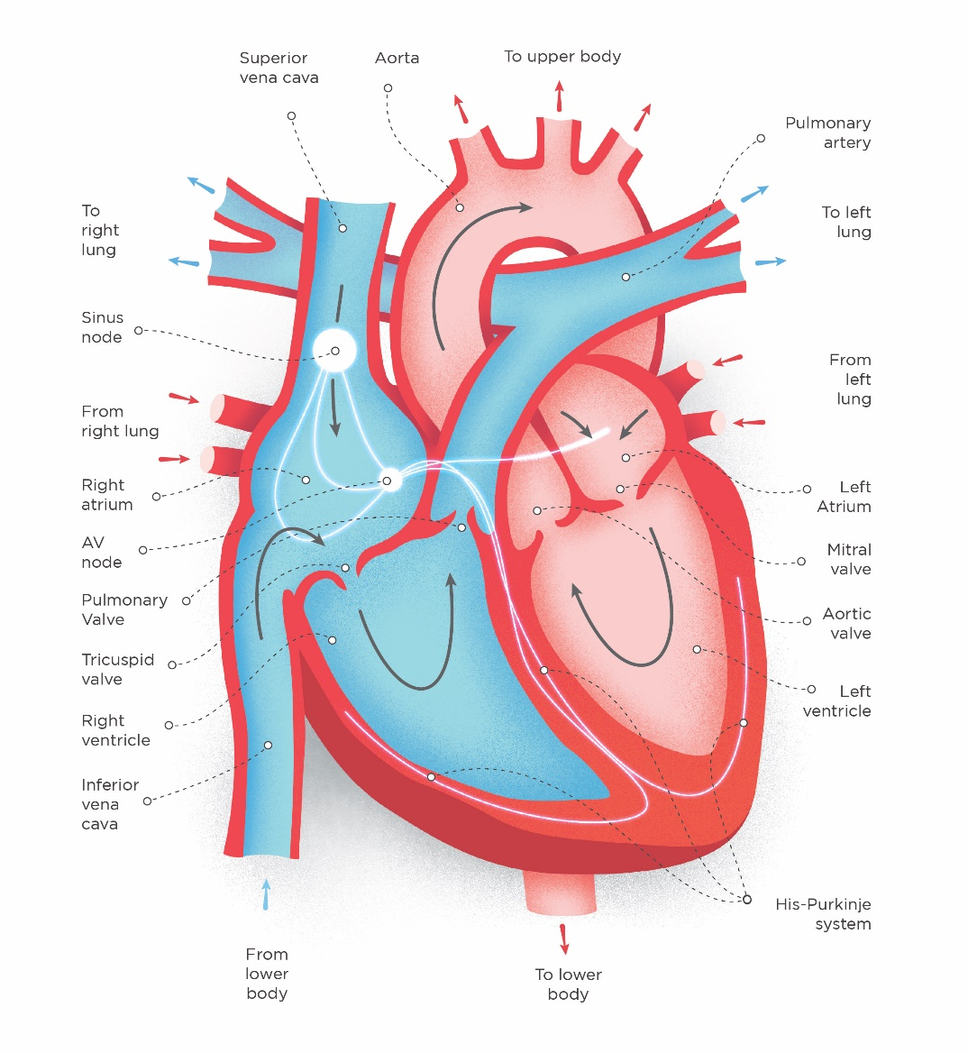

Heart Attack
A heart attack (myocardial infarction or MI) is a serious medical emergency in which the supply of blood to the heart is suddenly blocked, usually by a blood clot.
A heart attack is a medical emergency. Call 999 and ask for an ambulance if you suspect a heart attack.
A lack of blood to the heart may seriously damage the heart muscle and can be life threatening.
Symptoms of a heart attack can include:
- chest pain – a feeling of pressure, heaviness, tightness or squeezing across your chest
- pain in other parts of the body – it can feel as if the pain is spreading from your chest to your arms (usually the left arm, but it can affect both arms), jaw, neck, back and tummy
- feeling lightheaded or dizzy
- sweating
- shortness of breath
- feeling sick (nausea) or being sick (vomiting)
- an overwhelming feeling of anxiety (similar to a panic attack)
- coughing or wheezing
The chest pain is often severe, but some people may only experience minor pain, similar to indigestion.
While the most common symptom in both men and women is chest pain, women are more likely to have other symptoms such as shortness of breath, feeling or being sick and back or jaw pain.
- NSTEMI
An NSTEMI can be less serious than an STEMI because the supply of blood to the heart may be only partially, rather than completely, blocked. As a result, a smaller section of the heart may be damaged. However, an NSTEMI is still regarded as a serious medical emergency. Without treatment, it can progress to serious heart damage or STEMI.

- STEMI
An STEMI is the most serious type of heart attack where there is a long interruption to the blood supply. This is caused by a total blockage of the coronary artery, which can cause extensive damage to a large area of the heart. An STEMI is what most people think of when they hear the term "heart attack".

- PCI
Coronary angioplasty with stenting (also known as percutaneous coronary intervention or PCI) is a treatment that helps improve the blood supply to your heart. Many people find they can do more after the procedure and their symptoms, such as chest pain and breathlessness, get better. Most people can return to their normal lives within a few weeks after having a coronary angioplasty with stents.

- Angiography treatment
Coronary angiography can help determine whether there is a blockage or narrowing in the coronary arteries and, if so, to locate the exact place of the blockage or narrowing. The test involves inserting a thin tube (catheter), into one of the blood vessels in your groin or arm. The catheter is guided into your coronary arteries using X-rays.

A special fluid, called a contrast agent, is pumped through the catheter. This fluid can be seen on X-rays and studying how it flows around and through your heart can help locate the site of any blockage or narrowing. This helps a doctor who specialises in heart conditions (cardiologist) decide the best treatment for you.
If you experience a high-risk heart attack, the preferred treatment in the UK is emergency or primary PCI (also known as primary angioplasty) to restore blood flow to the heart as soon as possible to stop further damage.
Once you arrive at the hospital cath lab, a fine tube, known as a catheter, is passed to your heart arteries under local anaesthetic to find out where the blockage is. Then a balloon and wire mesh ‘stent’ will be used to open up the blockage and restore blood flow to your heart muscle. The catheter can be inserted from either a blood vessel in your groin (femoral artery) or your wrist (radial artery). The use of the wrist is associated with fewer complications including reduced bleeding and is now the most usual access point for the procedure.
Once a balloon has restored blood flow, a stent (a tiny scaffold which helps hold open the artery) is then put in place and will remain there. Other technological advances have been made, and most stents are now ‘drug eluting’, containing specific drugs which minimise the risk of the artery re-narrowing due to scar tissue growing around the stent as the artery heals.
Additional procedures:
- Adult Cardiac surgery
Heart surgery is an operation that helps to mend problems with the heart and treat heart disease. It aims to relieve the symptoms of heart disease and improve your quality of life.

- Emergency aortic surgery
An abdominal aortic aneurysm (AAA) is a bulge or swelling in the aorta, the main blood vessel that runs from the heart down through the chest and tummy.

- Coronary Artery Bypass Graft (CABG)
Coronary artery bypass surgery, also known as heart bypass surgery, is a procedure that treats coronary heart disease. Coronary bypass surgery is a type of surgery where the chest is opened and surgery is performed on the heart. It’s used to bypass – or ‘get around’ - the narrowed or blocked sections of your coronary arteries.

- Day-of-Surgery Admission (DOSA)
Day of surgery admission (DOSA) describes the process whereby patients are admitted to hospital and have surgery, on the same day.

- Valve replacement or repair
There are four valves in your heart. Each valve makes sure blood flows through the heart in the correct way. When there's an issue with one or more of the valves, surgery is an option to fix them.
More information is available at the NHS website or British Heart Foundation website.

Heart Failure
Heart failure occurs for a number of reasons. It is often a secondary effect of other heart problems such as a heart attack (when the heart muscle is damaged), damage caused by the increased strain on the heart from high blood pressure, or cardiomyopathy (a disease of the heart muscle), as well as other causes. It essentially means that the heart is failing to pump as well as it should and can cause symptoms such as weakness, breathlessness, fatigue and swelling around the legs. It cannot be cured but, in many cases, patients can manage their condition with drugs and other therapies.
More information can be found on the NHS website or British Heart Foundation website.
Cardiac Rhythm Management (CRM)
An arrhythmia is a disorder of the heart rhythm, and cardiac rhythm management is the treatment. The pumping of your blood around your body is controlled by the electrical conduction system in your heart. If there is an irregular rhythm (arrhythmia) this can cause serious problems, even leading to sudden cardiac arrest (SCA) where the heart stops completely, which without medical attention on the scene is often fatal. Many arrhythmias are manageable with medication or technological solutions such as pacemakers or implantable cardioverter defibrillators (ICDs) to regulate the rhythm of the heart, and modern techniques such as ablation, where the problem electrical pathways are destroyed so they cannot influence the heart’s rhythm.
Implantable electronic cardiac devices
The most common type of device implant is the pacemaker, which is a small device, usually implanted just under the collar bone, with one or more leads threaded down a vein to connect to the heart, which artificially takes over the function of your heart’s natural pacemaker, the sinus node. It works by continually monitoring the rhythm of your heart and when necessary, can trigger the heartbeat at the correct rate, to prevent it going too slowly or stopping altogether. Technological advances have led to the development of more complex devices, such as implantable cardioverter defibrillators (ICDs) which can shock the heart into a regular rhythm, if it develops a chaotic rhythm (ventricular fibrillation). Most ICDs can also function as pacemakers. There are also cardiac resynchronisation therapy (CRT) devices which are often used to treat heart failure, when the heart becomes enlarged and contraction happens at different times on each side.
Depending on the type of device and the patient, most device batteries last for 6-10 years. A few months prior to the battery running out, the entire device is replaced and connected to the existing lead(s) – this is known as a ‘box change’.
Catheter Ablation
Catheter ablation is done by passing a thin catheter into the heart via a vein or artery. It is used to treat some forms of abnormally fast heart rhythms, such as atrial fibrillation. The problem area which is causing the arrythmia is identified, and either thermal (heat) or freezing (cryo) treatment is delivered via the catheter, destroying small areas of tissue and causing scar tissue to form. This can either deactivate the area entirely from the electrical pathways of your heart so the electricity takes a different route, or stop a damaged area of heart muscle from causing abnormal electrical impulses which make your heart rhythm potentially dangerous.
Sudden Cardiac Arrest
Electrical signals are sent by the system which powers your heart to keep it beating and blood pumping around your body. If this system completely stops working for any reason, such as a chaotic abnormal heart rhythm developing, blood will stop being pumped and your brain is starved of oxygen, and you will become unconscious. You will often stop breathing.
Cardiac arrest is described by the British Heart Foundation as “the ultimate medical emergency”. This is especially so if it happens outside hospital. A few minutes of giving the right treatment can literally be the difference between life and death. Some arrhythmias can be fatal – ventricular tachycardia (VT) or ventricular fibrillation (VF). When this happens the heart rhythm becomes chaotic and rapid. Only a shock (defibrillation) can restore the normal rhythm. With the increased use of cardiopulmonary resuscitation (CPR) and automated external defibrillators (AEDs) held in ambulances and public places, more cardiac arrests are successfully treated. Unfortunately, the majority of patients suffering cardiac arrest still do not survive, either because there is nobody around to call paramedics and start CPR, or because help arrives too late. Implantable cardioverter defibrillators (ICDs, implanted under the skin with a small operation requiring only local anaesthetic) can automatically detect a cardiac arrest, and restore the normal heart rhythm with a shock or with pacing, within seconds. For this reason, they are offered to patients who have been lucky enough to survive a prior cardiac arrest, and those whose heart tests have shown are at significant risk of a cardiac arrest.
Congenital Heart Disease
Many heart problems develop during a person’s lifetime and are influenced by lifestyle as well as genetics but some, called congenital heart disease, are present from birth and develop in the womb.
As a new or expectant parent this will obviously be a frightening thing to hear, but techniques, care and understanding have advanced significantly over the past few decades so that the vast majority of babies survive well into adulthood with a good quality of life. Some congenital heart disease problems self-correct over time (such as a small ventricular septal defect (a type of hole in the heart)), and others do not need surgery and can be monitored and managed with medications if necessary.
Research has shown that congenital heart disease is managed better when it can be diagnosed before birth, at the routine scan offered to all pregnant women at 20 weeks. The heart’s structure has developed as early as 10 weeks of pregnancy and most major problems with the structure of the heart can often be detected with the ultrasound scan at the 20-week scan or even earlier.
For children who go on to need a procedure in the first year of life, around 50% of their congenital heart problems are currently picked up by the scan.*
*It is important to bear in mind that the Congenital Audit only publishes the success rate of detection before birth of congenital heart conditions found during ultrasound scans by sonographers linked to obstetric units at local hospitals, and only in those children who have survived pregnancy and have then required a procedure in infancy. The results underestimate national and local success in detecting cardiac conditions in the womb, as they do not include other possible outcomes following antenatal diagnosis, such as termination of pregnancy, or the child not undergoing a heart procedure in infancy.
As a baby grows in its mother’s womb a number of congenital heart conditions can develop. Some of these conditions include:
Hole in the heart – this is where there is an opening in the wall that separates either the filling chambers (atria) or pumping chambers (ventricles) of the heart (or both). The most common types are an atrial septal defect (ASD) where there is a hole between the right and left atria, or a ventricular septal defect (VSD) between the right and left ventricles. These holes affect the flow of blood through the heart so that extra blood goes into the lungs and, if large, may lead to breathlessness and failure of the baby to grow. Not all holes will need treatment and some small ones will close on their own in time (up to 20 years). However, if surgery is needed it is generally in infancy or early childhood, whilst some holes can be closed using a transcatheter device (‘keyhole’ procedure), usually by mid to late childhood. There is a need for subsequent monitoring through life, although further procedures are unlikely to be required later in life if no other congenital heart condition is present.
Hypoplastic left heart syndrome (HLHS) – a relatively rare condition where the left side of the heart does not fully develop and is much smaller. Multiple surgical procedures may be required in infancy and early childhood. It is often able to be detected in pregnancy, and 82.8% of the babies with this condition who had to have a procedure before one year of age had their condition detected before birth in 2021/22 in the UK (excluding Scotland) and Republic of Ireland. This has risen over the last decade from 77.9% in 2011/12.
Transposition of the great arteries with intact ventricular septum (TGA-IVS) – in a healthy heart the pulmonary (lung) artery is connected to the right pumping chamber (right ventricle) which pumps the blood to the lungs, whilst the left pumping chamber (left ventricle) pumps the blood around the body through the aorta (the body’s main artery). However, in this condition they are switched, and both great arteries are connected to the wrong pumping chambers. This means that the blood being circulated around the body is low in oxygen and the baby is ‘blue’ at birth. It’s likely that the baby will need an operation in the first couple of weeks of life. Again, this condition is often visible on an ultrasound scan at 20 weeks of pregnancy. In 2021/22 86.3% of babies with this condition, who had to have a procedure before one year of age, had it detected before birth in the UK (excluding Scotland) and Republic of Ireland. This has risen over the last decade from 40% in 2012/13.
Complete Atrioventricular Septal Defect (AVSD) – this is where there is a hole between the right and left side of the heart in the centre, between the atria (the upper chambers where blood enters the heart) and also between the ventricles (pumping chambers). This means that the pumping of oxygenated blood to supply the rest of the body is impeded. It is a condition often seen in babies with trisomy 21 (Down’s Syndrome). In 2021/22, 56.7% of babies with this condition, who had to have a 'corrective’ procedure before one year of age, had it detected before birth in the UK (excluding Scotland) and Republic of Ireland. This has risen over the last decade from 37.1% in 2012/13.
There can also be combinations of structural problems in different areas of the heart.
Tetralogy of Fallot (TOF) – is a combination of four structural heart abnormalities. It involves a narrow pulmonary (lung) valve/artery, impeding the supply of blood to the lungs, an enlarged right ventricle (see the diagram of a heart above), along with a large hole (ventricular septal defect - VSD) between the right and left ventricles, which are the two main pumping chambers. The entrance to the aorta, which supplies blood to the rest of the body, is found next to the hole with this condition, meaning that blood low in oxygen flows through it mixing with the oxygenated blood and causing the level of oxygen in the blood to be lower than normal. This condition normally means the baby will need to have an operation before the age of one year, and how early in life this is depends on how severe the narrowing of the pulmonary valve/artery is. In 2021/22 79.7% of babies in the UK (excluding Scotland) and Republic of Ireland who had to have a ‘corrective’ procedure within one year of birth were diagnosed with the condition in the womb. This has risen over the last decade from 32.6% in 2012/13.
More information about the different types of congenital heart disease can be found on the NHS website.

